Station A

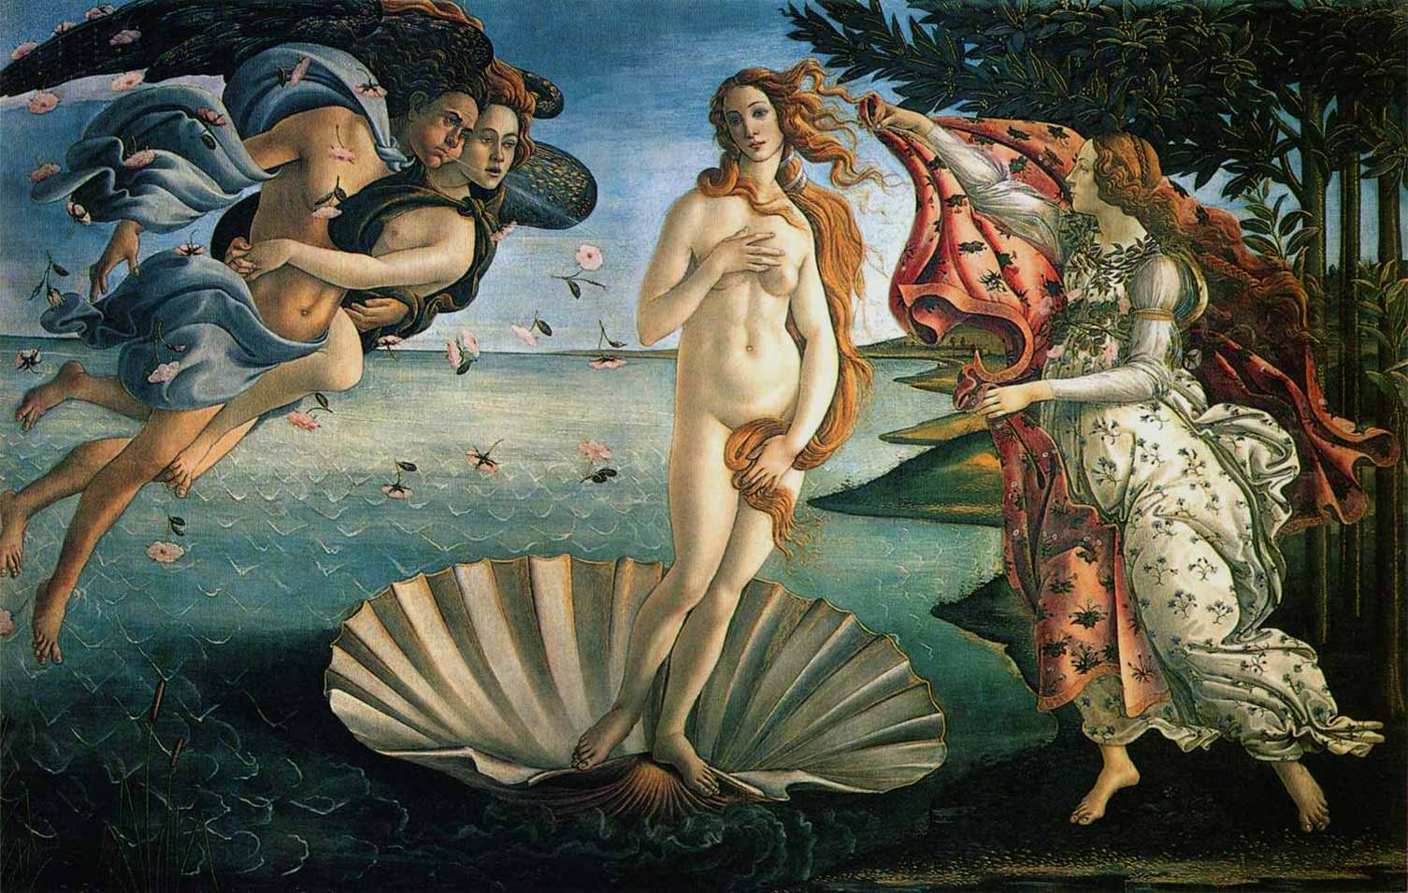

Station B

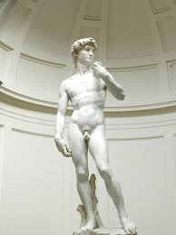

Station C

Hence, it is necessary for a prince wishing to hold his own to know how to do wrong, and to make use of it or not according to necessity. Therefore, putting on one side imaginary things concerning a prince, and discussing those which are real, I say that all men when they are spoken of, and chiefly princes for being more highly placed, are remarkable for some of those qualities which bring them either blame or praise; and thus it is that one is reputed liberal, another miserly...; one is reputed generous, one rapacious; one cruel, one compassionate; one faithless, another faithful.... And I know that every one will confess that it would be most praiseworthy in a prince to exhibit all the above qualities that are considered good; but because they can neither be entirely possessed nor observed, for human conditions do not permit it, it is necessary for him to be sufficiently prident that he may know how to avoid the reproach of those vices which would lose him his state...

Station D

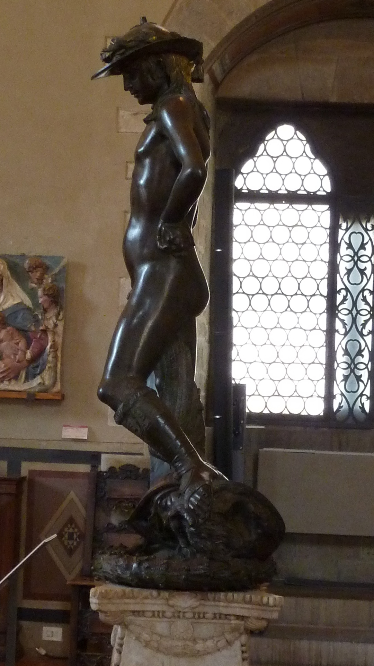
Station E

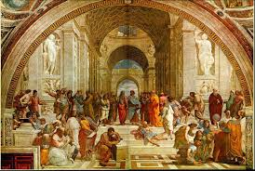

Station F

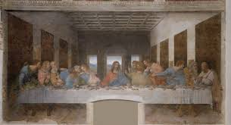

Station G

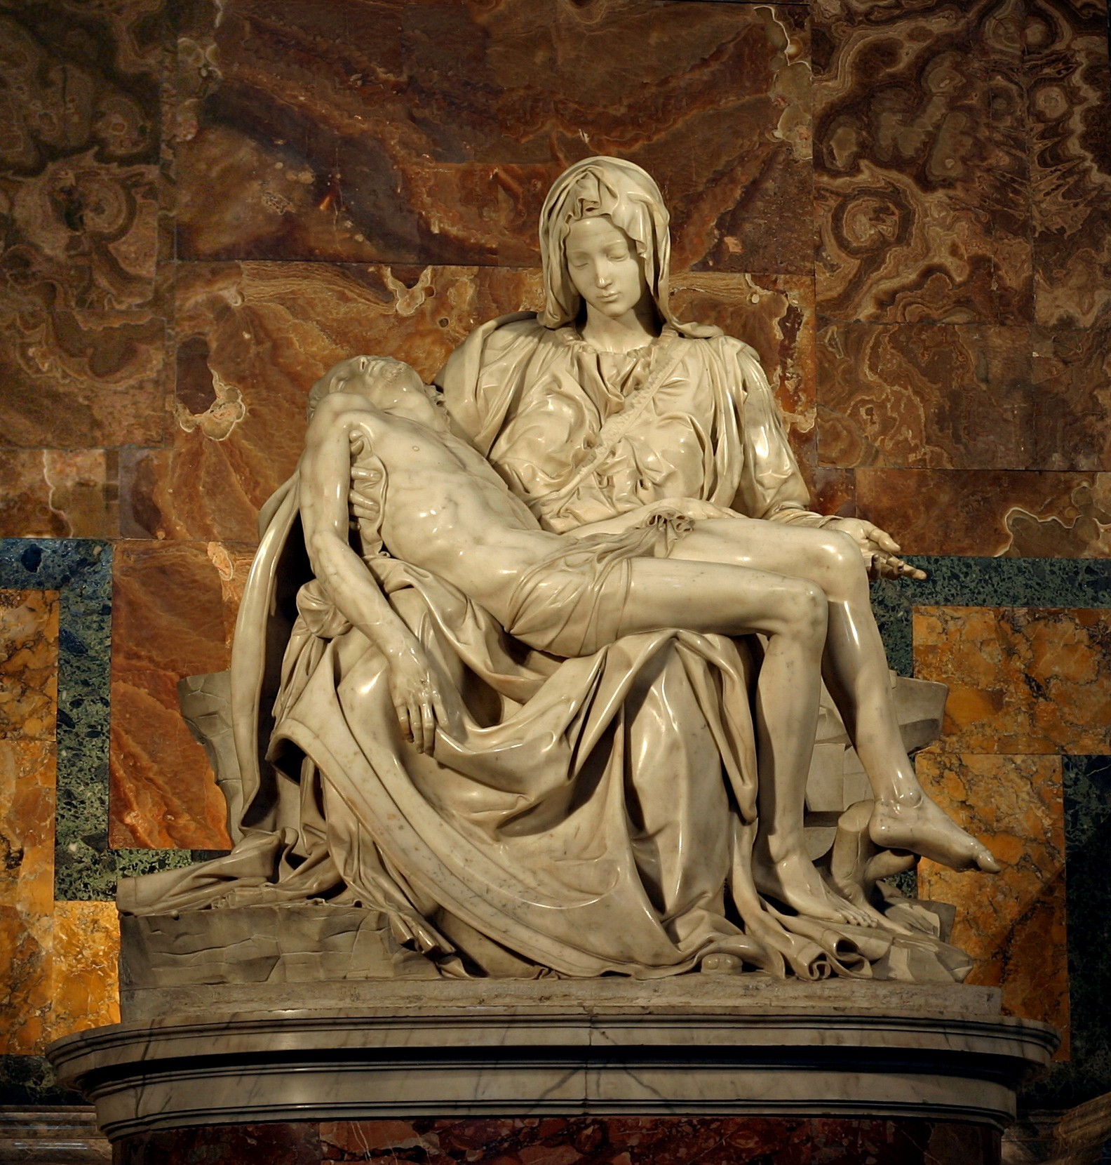

Station H

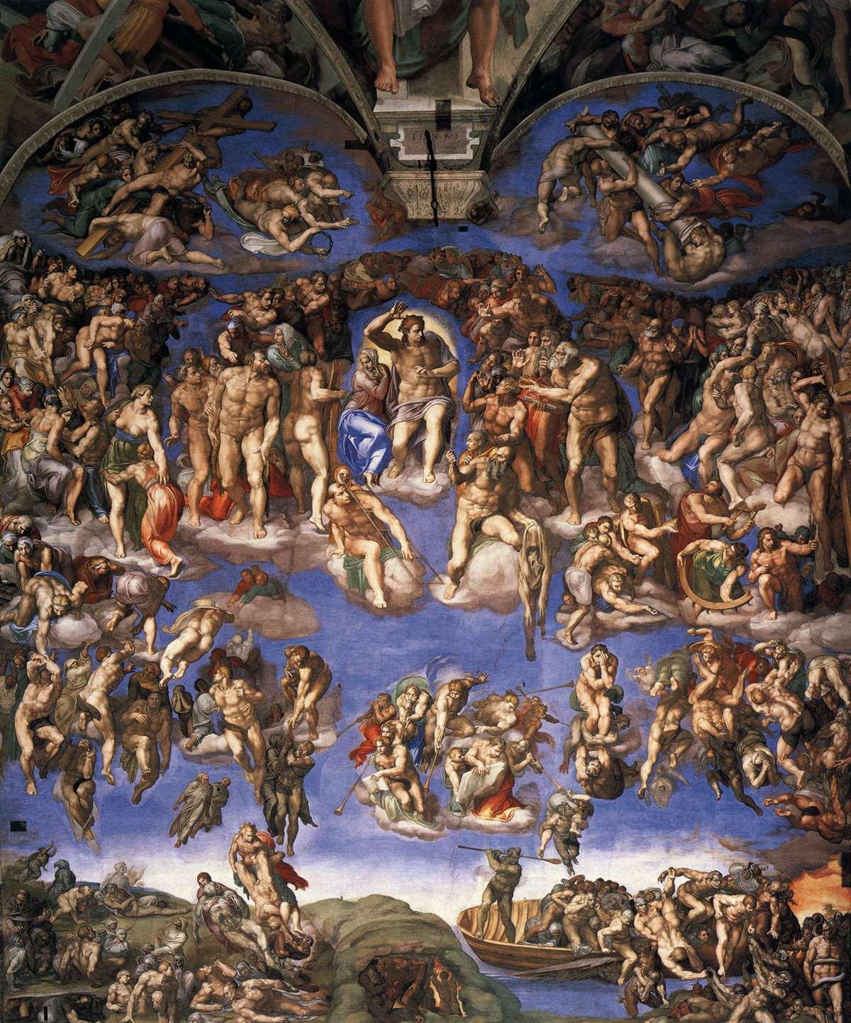

Station I

CLEOPATRA:
This proves me base:
If she first meet the curled Antony,
He'll make demand of her, and spend that kiss
Which is my heaven to have. Come, thou
mortal wretch,
To an asp, which she applies to her breast
With thy sharp teeth this knot intrinsicate
Of life at once untie: poor venomous fool
Be angry, and dispatch. O, couldst thou speak,
That I might hear thee call great Caesar ass
Unpolicied!

